**Homework 1**

**Question 1: Logic**

1. Explain how to write A ∨ B using only ¬ and →. Can you do the same with A ∧ B? Rewrite the following statement without any ∨ or ∧ symbols. Finally, decide if the statement is satisfiable.

((A ∧ (B ∨ C)) → ¬(A ∧ C)) ∨ C

* A ∨ B → A or B: True if A or B is true, meaning that A and B would have to be the implication of the other. The only condition for false is if both are false. For the implication, the truth table is false if and only if A is false, but B is true.

$$P → Q≡ ¬P ∨ Q$$

$$A ∨B can be rewritten as (¬A → B )$$

|  |  |  |
| --- | --- | --- |
| A | B | A ∨ B |
| T | T | T |
| T | F | T |
| F | T | T |
| F | F | F |

|  |  |  |
| --- | --- | --- |
| A | B | (¬A → B) |
| T | T | T |
| T | F | T |
| F | T | T |
| F | F | F |

Can you do the same with A ∧ B?

De Morgan’s Law

$$P → Q≡ ¬P ∨ Q$$

¬(P ∨ Q) $≡$ ¬P ∧ ¬Q

$$A→B≡\left(¬A ∨B\right)$$

$$\left(¬A ∨B\right) ≡¬(A ∧ ¬B)$$

$$A→B≡¬(A ∧ ¬B)$$

|  |  |  |
| --- | --- | --- |
| A | B | A ∧ B? |
| T | T | T |
| T | F | F |
| F | T | F |
| F | F | F |

¬ (A → ¬B)

|  |  |  |
| --- | --- | --- |
| A | B | ¬ (A → ¬B) |
| T | T | T |
| T | F | F |
| F | T | F |
| F | F | F |

Finally, decide if the statement is satisfiable.

((A ∧ (B ∨ C)) → ¬(A ∧ C)) ∨ C

Satisfiable: Sometimes true. Requirement is for one set of conditions to yield true.

|  |  |  |  |  |
| --- | --- | --- | --- | --- |
| A | B | C | ((A ∧ (B ∨ C)) | ¬(A ∧ C)) ∨ C |
| T | T | F | T | T |

((A ∧ (B ∨ C)) → ¬(A ∧ C)) ∨ C

Substituting the values in

((T ∧ (T ∨ F)) → ¬(T ∧ F)) ∨ F

((T ∧ T) → ¬F ∨ F

T → T

Because this series of inputs are true, then the statement is satisfiable.

1. Convert each of the sentences below into logic, by defining propositions (no predicates). Next, take the negation of the logical statement, and write it in English.

* I pass this course only if I do all the exercises
  + P: I pass this course
  + E: I do all the exercises
  + P→E
  + Negation:
    - I didn’t do all of the exercises and I passed the course.
    - ¬(P→E)
    - ¬E∧P
* I need to wear a hat whenever it is sunny
  + H: I wear a hat
  + S: It is sunny
  + S→H
  + Negation:
    - It is sunny and I’m not wearing a hat.
    - ¬H∧S
* It is sufficient to wear a mask to keep from getting sick
  + M: Wear a mask
  + S: Getting sick
  + M→¬ S
  + Negation:
    - I am wearing a mask but I am also sick.
    - S∧M
* If you get sick, it doesn’t mean that you didn’t wear a mask
  + M: Wearing a mask
  + S: Getting Sick
  + ¬ (S→¬M)
  + Negation:
    - ¬¬ (S→¬M) = (S →¬M)
    - Double negation
    - If you are sick, then you didn’t wear a mask.

1. Suppose that a proposition is not satisfiable. If we take its negation, does that mean the negated statement is satisfiable? Is it true that the negated statement is valid? Explain your answer.

A propositional statement is satisfiable if its truth table has some true statements. If a proposition is not satisfiable, then it means that there are no true statements, only false statements. As such, the negation of such a statement is one that has only true statements. The condition for the statement to be valid is to have all true statements.

Because for the condition to be satisfiable is to have atleast one true statement, the negated statement can considered valid and satisfiable as it has all true statements.

|  |  |  |  |
| --- | --- | --- | --- |
| A | B | P(A, B) | ¬P(A, B) |
| T | T | F | T |
| T | F | F | T |
| F | T | F | T |
| F | F | F | T |

1. Is it possible to satisfy the following: ”If I go to Italy on vacation, then I need to buy new clothes. If I don’t buy new clothes, then I can afford to go on vacation. A vacation takes place in either Italy or France or Mexico. If I don’t go on vacation to France, then I will not go to a museum. I must either go to a museum or buy new clothes. I can’t go on vacation to more than one country.” Define your propositions, and justify your answer.

* V: Going on vacation
* F: Going to France
* M: Going to Mexico
* MU: Going to a museum
* I: Going to Italy
* C: Buying new clothes

V∧¬ [(M∧F∧I) ∨ (M∧F) ∨ (M∧I) ∨ (F∧I)]

* If going on vacation, it must be in one of the three countries of France, Italy, or Mexico.

I→C

* If I go to Italy, I must buy new clothes

¬C→V

* If I don’t buy new clothes, I can afford to go on vacation.

¬F→¬MU

* If I don’t go on vacation to France, then I will not go to a museum.

MU⊕C

* I must either go to a museum or buy new clothes. The English imply that this is an exclusive-or scenario; must choose one or the other.

Satisfiable Scenario:

|  |  |
| --- | --- |
| V | T |
| F | T |
| I | F |
| M | F |
| MU | T |
| C | F |

* V has to be true since there’s no option to not go on vacation mentioned in the paragraph.
* France and Italy have a determined scenario where only France can visit a museum, and Italy must buy new clothes.
  + Because only one country can be chosen to visit, the other two countries have to be false
* Clothes cannot be bought so that the person can afford to go on vacation
  + C has to be false
  + Because C is false, Italy cannot be a choice
  + This is because if Italy is chosen, then new clothes must be bought
* This leaves Mexico and France as a choice
  + However, if France is not chosen, then the person does not go to a museum
  + The person has to choose between buying clothes or visiting a museum
  + MU must be true
  + Therefore, France must be chosen so that the person will visit a museum
* Because the person visits France, the person has access to a museum
  + New clothes will be false due to the exclusive-or condition
  + This means the person can afford to go on vacation
  + This means the person did not choose Mexico or Italy

**Question 2: Predicate Logic and Sets**

1. Let C = {a, b, c, d}. Assume that a, b are studying and a, b, d are passing this course. Let S(x) be the predicate for studying and P(x) be the predicate for passing. The domain below is the set C. For each of the statements below, decide whether or not they are true. Explain your answer.

* Studying: A, B
  + Not Studying: C, D
* Passing: A, B, D
  + Not passing: C

•∀x(S(x) → P(x))

* **True**:
  + Statement: Is it sufficient for everyone to study in order to pass a class.
  + Requirement: Everyone in S(x) must be in P(x)
    - A and B studied and they both passed.

• (∀xS(x)) → (∃xP(x))

* **False:**
  + Statement: If all students studied, then there will be some students who are passing.
    - S(x): All of the students who are studying
    - P(x): Some of the students are passing
    - The domain of S(x) isn’t necessarily the same domain of P(x)
  + Requirement: Everyone has to be studying for atleast one person to be passing
  + C and D are not studying but A, B, and D are passing.

• ∃x¬(P(x) → S(x))

* **True**:
  + Statement: For some of the people, it is not true that they passed whenever they studied.
  + Equivalent to ∃x(P(x) ∧ ¬S(x)) (De Morgan’s Law)
  + Requirement: Atleast one person who passed but did not study
    - D passed, but he did not study.

1. Translate the following into logic, assuming the domain of people is students. You may use predicates for: ’a student being in a class’ and ’a graduating student’ and ’being patient’.

x: Students

y: Class

P(x): being patient

C(x, y): Student x taking class Y

G(x): Graduating student

* No class contains all students
  + ¬∃y∀x (C(x,y))
* Every class has at least two students
  + ∀y∃x∃w (C(x, y) ∧ (C(w, y) ∧ w != x))
* Some students are taking all classes.
  + ∃x∀y(C(x, y))
* A student can graduate only if they are taking at least two classes.
  + A student in this condition is referring to all students under this scenario.
  + ∀x(G(x) → ∃y∃z (C(x, y) ∧ (C(x, z) ∧ z != y )))
* There are some students who are registered in all classes but are not graduating.
  + Some doesn’t mean all the students in the university. It means there exists some.
  + ∃x∀y (C(x, y) ∧ ¬G(x))
* All graduating students are patient
  + ∀x(G(x) →P(x))

1. Convert the following statement into logic: “Every non-zero integer is either an even number or an odd number”. You cannot use predicates! Take the negation of your answer and simplify so that there are no ¬ symbols left.

$$\left\{\left(\frac{Z}{2} ⊆± N\right)∨\left( Z⊆±(2N+1\right) \right\}$$

* All even numbers when divided by 2 must be in the subset of natural numbers.
  + Odd numbers or numbers that are not integers would become rational numbers if divided by 2.
* All odd integers must be in the subset of (2k + 1).
  + All odd numbers can be found through 2k + 1.
* Negative numbers still count as being odd or even, but non-integers would lead to real or rational numbers which may not be in the subset of whole numbers.
* Negation: A non-zero integer cannot be divided by 2 to form a positive or negative natural number, and a non-zero integer is not in the set of 2n + 1 where n is all natural numbers.
  + Even: A non-zero integer, when divided by 2, is not in the subset of positive or negative natural numbers.
  + Odd: A non-zero integer is not in the subset of positive or negative set of (2N + 1

$$¬\left\{\left(\frac{Z}{2} ⊆± N\right)∨\left( Z⊆±(2N+1\right) \right\}$$

$$\left\{¬\left(\frac{Z}{2} ⊆± N\right)∧¬\left( Z⊆±(2N+1\right) \right\}$$

$$\left\{\left(\frac{Z}{2} ⊄± N\right)∨\left( Z⊄±(2N+1\right) \right\}$$

1. Let T(x) be the predicate for person x taking a positive test. Let S(x) be the predicate for person x being sick. Translate the following into English. Determine if the statements are equivalent, explain your answer

* ∀x(T(x) → S(x))

Everyone takes a positive test only if they are sick.

* (∀x, ¬T(x)) → (∃x, ¬S(x)))

If everyone did not take a positive test, there are some people who are not sick.

|  |  |  |
| --- | --- | --- |
| T | S | T(x) → S(x) |
| T | T | T |
| T | F | F |
| F | T | T |
| F | F | T |

* If a person is sick, then he/she would receive a positive test.
* The person would not receive a positive test for a disease he/she does not have.

|  |  |  |
| --- | --- | --- |
| T | S | (∀x, ¬T(x)) → (∃x, ¬S(x))) |
| T | T | T |
| T | F | T |
| F | T | F |
| F | F | T |

* The domains sets of T(x) and S(x) are different in this case.
* If everyone did not take a positive test, then cases where there are no sick people are false.
* If not everyone took a positive case, then there could be cases where someone is sick.

The two statements are not equivalent.

1. Give an example of sets A, B, C, such that B ⊆ C and B ∈ C and A ∈ B and |B| = 6

A={(1, 2)} (1, 2) ∈ {(1, 2)}

B={(**1, 2)**, 3, (4, 5), 6, 7, 8} |B| = 6, sets within a set count as one element

(1, 2) -> element 1

3-> element 2

(4, 5) -> element 3

6-> element 4

7-> element 5

8-> element 6

C={**(1, 2), 3, (4, 5), 6, 7, 8**, (9, 10), (11, 12)} B ⊆ C, B ∈ C

The entire set of B is located in C, meaning

B ∈ C. B ∈ C implies B ⊆ C since C contains more elements than the set B as well.

1. Decide if the following are true. Justify your answer.

* if A ∩ B $≠$ A then it must be that A − B $≠$ A

**True**

There are two possible scenarios for A ∩ B $≠$ A to occur

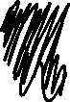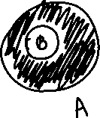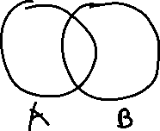

A ∩ B $≠$ A means that A and B are not disjointed. There is an element within B that is not in the set A. The statement means that the entire set of A is not a subset of B.

$$A ∩ B = A is equivalent to A⊆B$$

$$A ∩ B ≠ A is equivalent to A⊈B$$

A − B $≠$ A means that the set B is not disjointed with the set A. There has to be an element inside B and inside A such that the set subtraction would affect the set of A.

$$A-B ≠A means that A∩B ≠ ∅$$

$$The only scenario where A-B=A is if the sets A and B are disjointed$$

$$Meaning that A-B ≠A means that A and B must have an intersection$$

A = {1, 2}

B = {2, 4}

A ∩ B = {2} != A

A – B = {1, 2} – {2, 4} = {1}

* P({1, 2, 3}) = P({1, 2}) ∪ P({2, 3})

**True**

The union of two sets count the elements from both sets into one. Any elements found in both sets get considered as one element.

x ∈ A ∪ B ⇔ x ∈ A or x ∈ B

[Or] means that as long as the element is located in set A or B, then it will be included in the union.

This will count 1 and 2 from P({1, 2}) and 2 and 3 from P({2, 3}). This combines the two to form P({1, 2, 3}), treating the 2 found twice as one element.

**Question 3: Functions**

1. Decide if the following functions are surjective or injective or bijective or not defined.

Injective: One-to-one. Every element pair must be unique

Surjective: Onto. Every element in B must be paired from an element from A.

Bijective: Injective and surjective

* f : ℤ → ℚ, f(n) = n2
  + **Not Defined**
  + **Not Surjective**: Negative integers have to A variant. Every squared integer will always be positive.
  + **Not injective** because having a negative A value will lead to a positive B pair, meaning that there will be atleast two A values for every B integer unit. The range of B is all positive numbers.
  + In addition, while prime numbers are within the domain of rational numbers, they can’t be matched with any integers.
    - F(-1) = 1
    - F(1) = 1
    - F(x) !< 0, no solution for negative integers of B
    - F(x) = 3 has no matching integer value, only rational numbers.
  + There are atleast two pairs for every n value since integers include their negative variants.

# f : ℤ → ℕ, f(n) = √n2

* + **Surjective but not injective**
  + **Surjective**: Because B is all natural numbers, they are all positive values.
    - √n2 yields the same number but always positive.
    - F(1) = 1
    - F(2) = 2 …
    - F(-1) = 1
    - F(-2) = 2 …
    - F(±x) = y where y ≥ 0
  + **Injective**: Not every B value has a unique pair. Z’s negative integers still pair with the same values as their positive counterparts.
    - F(-1) = 1
    - F(1) = 1
* f : R+ → R, f(n) = √ n
  + **Injective but not surjective**
  + A is all positive real numbers while B is all real numbers.
  + **Surjective**: Square roots are considered irrational numbers which fit under real numbers. Every positive real can be square rooted, but negative real numbers cannot be paired under these conditions (complex numbers do not count).
  + **Injective**: Every real number has its own unique square root, so the function is injective.
    - f(1) = 1
    - f(2) = √2
    - f(3) = √3
    - f(n) != -2
* f : P(A) → ℕ, f(B) = |(B)| where A = {1, 2, 3}
  + **Not defined**
  + P(A) = {Ø, (1, 2, 3), (1), (2), (3), (1, 2), (1, 3), (2, 3)}
  + B is asking for an element from the set of the powerset of A.
  + **Injective:** The empty set is not a number; it does not contain a number. As a result, the empty set will not be a part of the natural numbers.
  + **Surjective**: Grabbing a number from the powerset shows duplicates of the three numbers.
    - The numbers of 1, 2, and 3 appear four times
    - |B| of (1), (2), (3) each equals to the cardinality of 1
    - |B| of (1, 2), (1, 3), (2, 3) each equals the cardinality of 2.

1. Suppose that A and B are both finite sets, and that |A| < |B|. Does an injective function f : B → A exist? Explain your answer

**Does not exist**

Injective: All sets of A will be a part of B. This implies that if f(a) = f(b) also means that a = b or that |A| has to be <= |B| for A→B to be injective.

It is impossible to have B → A to be injective if |A| < |B|. There will not be enough values in A to be paired with values of B.

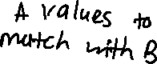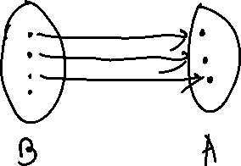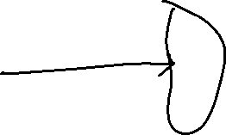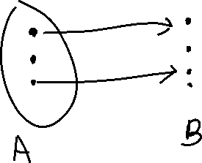

1. Let f(x) = √ x, defined on f : N → R. Let A = {x| − 5 ≤ x ≤ 5}. Find f-1 (A).

|  |  |
| --- | --- |
| A (N) | f-1(A) (R) |
| -5 (Not a natural number) | N/A |
| -4 (Not a natural number) | N/A |
| -3 (Not a natural number) | N/A |
| -2 (Not a natural number) | N/A |
| -1 (Not a natural number) | N/A |
| 0 | 0 |
| 1 | 1 |
| 2 | √2 |
| 3 | √3 |
| 4 | 2 |
| 5 | √5 |

$$f^{-1}\left(A\right)=x^{2}$$

$$f^{-1}\left(A\right)=\{0, 1, \sqrt{2}, 2, \sqrt{3},√5\}$$

* Natural numbers do not include the negative numbers, so f-1(A) cannot be found for the negatives.
  + This is assuming 0 is a natural number.
* Complex numbers such as square root of -2 are not real numbers.

1. Let A = {x ∈ R|10 < x < 11}. For each of the following sets, state whether the set is infinite or finite, and whether it is countable or uncountable, and finally whether or not it has the same cardinality as A . Justify your answer.

Same cardinality if |A| ≤ |B| or if A is bijective to B.

Cantor’s diagonal theorem states that the set of real numbers is not countable. It is impossible to construct a bijection between N and R[1].

* {x ∈ N|0 < x < 20}
  + Countable and finite
    - The set of all natural numbers are the whole numbers from 1 to 19.
    - Finite number because it has the upper limit of 20 and is countable.
    - The set B is finite while the set A is infinite. This means |A| > |B|, meaning that A and B do not share the same cardinality because an uncountable set is larger than the countable set.
* {x ∈ R|0 < x < 5}
  + Uncountably infinite
  + All real numbers can mean an infinite amount of numbers in between 0 and 5 in an open interval.
  + It is uncountable because there is no pattern for discerning all possible numbers between two numbers (Cantor’s diagonal argument).
    - F(x) = 5(x-10) would yield the domain of B.
  + The powerset of B is the same as A because they are both uncountably infinite, meaning that |A| = |B|. It would be possible to create a bijection. The set B has the same cardinality as the set A.
* {x ∈ Z| x is a multiple of 7}
  + Countably infinite
  + The set has a discernable pattern of f(x) = 7x which extends infinitely negative and positive, making it countable
  + Cantor’s theorem states that uncountably infinite sets are larger than countably infinite sets due to the nature of the powerset being infinitely larger than a countably infinite set.
  + This means that |A| > |B|, so they do not share the same cardinality.

**Question 4: Growth of Functions**

1. Determine if the following are true using the definitions from class. Make sure you justify your result!

* f(n) = n7/4 + log *n* is O(n7/4)

Proof by definition:

Fractional power is larger than logarithmic time.

$$f\left(n\right)=n^{\frac{7}{4}}+\log{n}$$

Checking the upper bound of the highest order

$$Condition: f\left(n\right)≤C*g\left(n\right) for all n>k$$

$$n^{\frac{7}{4}}+\log{n}≤c(n^{\frac{7}{4}})$$

$$n^{\frac{7}{4}}+\log{n}≤cn^{\frac{7}{4}}$$

$$\frac{\log{n}}{n^{\frac{7}{4}}}≤c$$

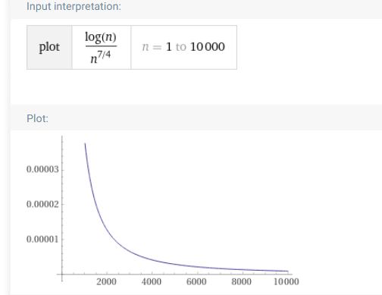

* The equation is true for all n ≥ 1
* f(n) = n7/4 log *n* is O(n2)

Summation growth approaches a bound.

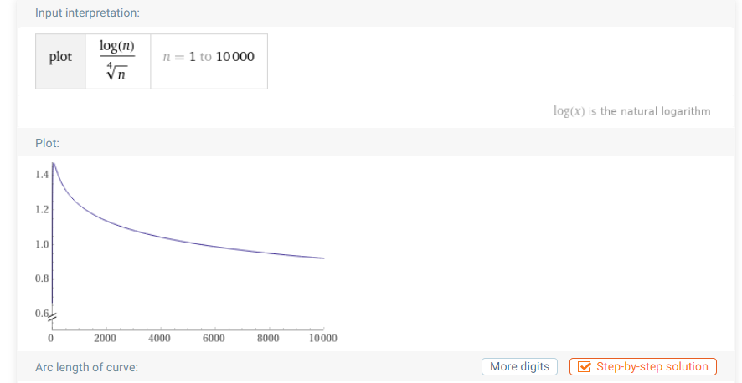

1. For the following functions, decide if f(n) is O(g(n)) or f(n) is Ω(g(n)) or both.

* f(n) = √n, g(n) = (log *n*) + (log *n*)2

**f(n) is** Ω **(g(n))**

Fractional power has higher precedence than poly logarithmic time. Sqrt(n) will grow faster than g(n)

$$\sqrt{n}=c(\log{n+{\left(\log{n}\right)}^{2})}$$

$$\frac{n^{\frac{1}{2}}}{{(log{n})}^{2}}=c*(\frac{1}{\log{n}}+1)$$

$$\frac{n^{\frac{1}{2}}}{{\left(\log{n}\right)}^{2}}/\left(\frac{1}{\log{n}}+1\right)=c$$

$$f\left(n\right)≥g(n)$$

* f(n) = (3n + log *n*)(n2 + 2n log n), g(n) = 6n

**f(n) is** Ω **(g(n))**

f(n) = (3n + log *n*)(n2 + 2n log n)

$$f\left(n\right)=3^{n}n^{2}+6^{n}\log{n}+n^{2}\log{n}+2^{n}{\left(\log{n}\right)}^{2}$$

6n represents the highest-order element of f(n), so that will be used to compare f(n) and g(n)

$$3^{n}n^{2}+6^{n}\log{n}+n^{2}\log{n}=c6^{n}$$

$${\left(\frac{1}{2}\right)}^{n}n^{2}+\log{n}+\frac{n^{2}\log{n}}{6^{n}}=c$$

$$\log{n=c}$$

$$f\left(n\right)≥g\left(n\right)$$

Because of the log n, f(n) will always form the upper bound for g(n)

* f(n) = , g(n) = 4n2

**Because f(n) and g(n)’s asymptotic bounds are approximately the same, f(n) is both O(g(n)) and Ω(g(n))**

Ignoring the +2, linear summation can be simplified as Sn = n(n+1)/2.

N2/2 is the highest order term is the highest-order term in f(n). n/2 will not be considered when determining the asymptotic bound of f(n) because it is smaller than n2/2.

* f(n) = log n0.2, g(n) = n0.2 + (log n)0.2

**f(n) is O(g(n))**

g(n) has higher precedence due to having fractional power time while f(n) has poly logarithmic time.

$$f≤cg(n)$$

$$\log{n^{0.2}}≤c(n^{0.2}+{\left(\log{n}\right)}^{0.2})$$

$$1≤c(\frac{n^{0.2}}{{\left(\log{n}\right)}^{.02}}+1)$$

$$f\left(n\right)≤g(n)$$

G(n) still grows infinitely compared to f(n), proving that g(n) is larger than f(n) and as such, g(n) is the upper bound for f(n)

1. Prove that n + 3n2 · log n is not O(n2)

* Under the family, a polynomial time is larger than logarithmic time

$$n+3n^{2}*\log{n≤c*f\left(n\right)}$$

$$n+3n^{2}*\log{n}≤cn^{2}$$

$$\frac{1}{n}+3\log{n}≤c$$

$$f\left(n\right)≥g(n)$$

3 log *n* grows infinitely large, so no matter what c is, the equation will outgrow c.

$$n+3n^{2}*\log{n is greater than}O\left(n^{2}\right) complexity time.$$

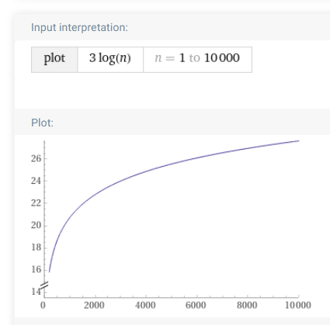

**Question 5: Sequences, Summations**

1. Find the sum if it exists. Justify your answer.

$$\frac{1}{3}+\frac{1}{2}+\frac{3}{4}+\frac{9}{8}+\frac{27}{16}+…$$

* The pattern is that each term is multiplied by 3/2
  + 1/3 -> 3/6 -> ½ -> ¾ -> 9/8 …
* The sum can be found as this case is an example of the geometric series
$$\sum_{k=0}^{∞}{{\frac{1}{3}*(\frac{3}{2})}^{k}}$$

$$Geometric Series Sum:\sum_{k=1}^{∞}{a*r^{k}}=a\frac{\left(1-r^{n}\right)}{1-r}, where-1<r<1$$

$$a=\frac{1}{3},r=\frac{3}{2}, r>1$$

* **The series has no upper bound because it grows infinitely. It has no sum.**

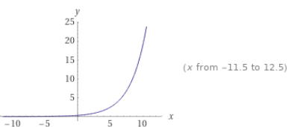

1. Find the sum if it exists:

$$\sum_{n=1}^{∞}{{\left(-2\right)}^{[\frac{n}{2}]}}$$

Geometric series with a = 1 and r = -2. This series extends downwards infinitely.

$$r< -1, meaning that there is no lower bound. No sum for this series.$$

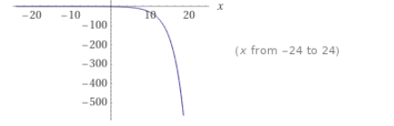

1. Find the sum (using a formula from class): (read carefully)

$$\sum_{i= -2}^{∞}{\frac{2^{i-1}}{3^{i}}}$$

$$\sum_{i= -2}^{∞}{\frac{2^{i-1}}{3^{i}}}= \sum_{i= 0}^{∞}{2^{-1}*\frac{2^{i}}{3^{i}} }$$

Must add compensation for the summations after the calculations

$$2^{-1}\sum_{i= 0}^{∞}{{\left(\frac{2}{3}\right)}^{i}}$$

$$\sum_{k=1}^{∞}{a*r^{k}}=\frac{\left(1-r^{n}\right)}{1-r}$$

$$a=\frac{1}{2},r=\frac{2}{3}, -1≤r≤1$$

$$\frac{1}{2}*\sum_{i= 0}^{∞}{{\left(\frac{2}{3}\right)}^{i}}=\frac{1}{2}*\frac{(1-{\left(\frac{2}{3}\right)}^{i}}{1-\frac{2}{3}}+\left[Term-2\right]+[Term-1]$$

$$\frac{1}{2}*\frac{1}{\frac{1}{3}}+\frac{2^{-2-1}}{3^{-2}}+\frac{2^{-1-1}}{3^{-1}}$$

$$\frac{1}{2}*3+\frac{9}{8}+\frac{3}{4}=\frac{27}{8}$$

1. On day one I deposit $100 into my account. Every day after that I deposit exactly half of what I deposited the previous day. How much money do I have in the account after 50 days? If I keep doing this for n more days, will I ever have a balance of 200 in the account? Explain why or why not.

Because the amount of money being deposited is decreasing by a consistent amount each time, the total amount will reach an upper bound eventually, meaning that this case does have a sum.

$$\sum_{x=0}^{∞}{\frac{100}{2^{x}}}$$

Total sum:

$$\sum_{x=0}^{∞}{\frac{100}{2^{x}}}=100\sum_{x=0}^{∞}{2^{-x}= }100\sum_{x=0}^{∞}{{\left(\frac{1}{2}\right)}^{x}, -1≤r≤1}$$

$$a\frac{\left(1-r^{n}\right)}{1-r}=100*\frac{\left(1-{0.5}^{n}\right)}{1-0.5}=200*(1-{0.5}^{n})$$

$$With n= ∞, that means 0.5 approaches 0 infinitely$$

$$200*\left(1-0\right)=200$$

**The sum is 200, meaning that your balance will have a sum of 200.**

* How much money do I have in the account after 50 days?

$$200*\left(1-{0.5}^{n}\right), n=50$$

$$200*\left(1-{0.5}^{50}\right)≈200-{0.5}^{50}=199.999999999999999111821$$

1. https://jlmartin.ku.edu/~jlmartin/courses/math410-S13/cantor.pdf